**Marketplace Technical Foundation - [Bandage Store]**

**System Architecture Overview**

Our E-commerce clothing store will have a robust architecture to ensure seamless user interaction, efficient data flow, and scalability for future growth. The architecture integrates **Next.js for the frontend**, **Sanity CMS for backend data management**, and **third-party APIs** for logistics and payments.

**Diagram:**

**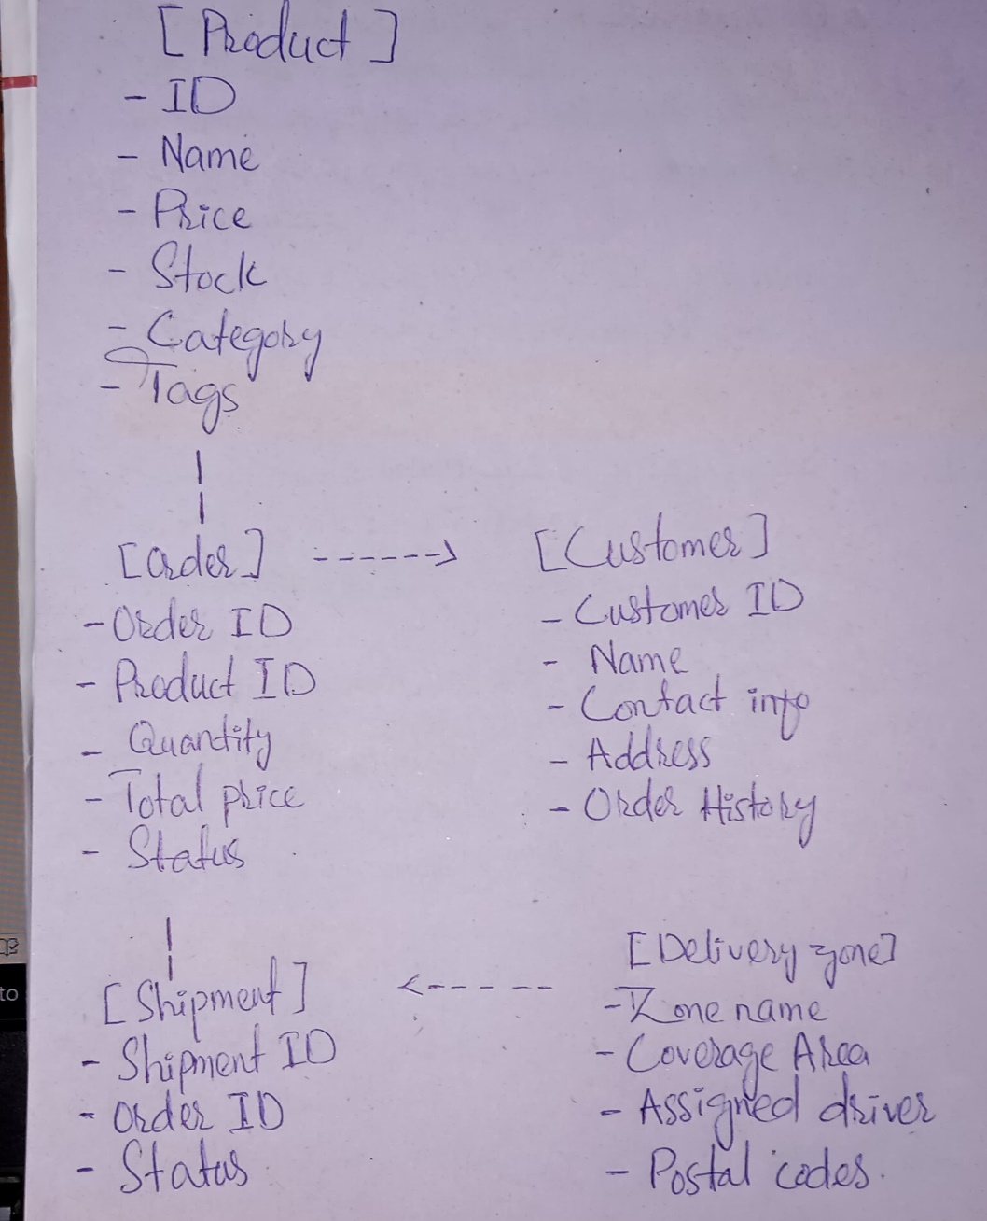**

**Component Roles:**

* **Frontend (Next.js):**
  + A user-friendly interface to browse products, manage the cart, and complete orders.
  + Ensures responsiveness for both mobile and desktop users.
* **Sanity CMS:**
  + Acts as the central hub for managing product data, customer information, and orders.
  + Provides APIs to interact with the backend for data retrieval and storage.
* **Third-Party APIs:**
  + **Shipment Tracking API**: Fetches real-time updates for orders.

**Key Workflows**

1. **User Browsing Products:**
   * User visits the homepage.
   * Frontend fetches product categories and listings from Sanity CMS via /products endpoint.
   * Products are dynamically displayed with options to filter and search.
2. **Adding Products to Cart:**
   * User selects products and adds them to the cart.
   * Cart is updated in real time, showing product details, quantity, and total cost.
3. **Placing an Order:**
   * User proceeds to checkout and submits order details.
   * Frontend sends data to /orders endpoint, which saves the order in Sanity CMS with a "Pending" status.
4. **Tracking Shipment:**
   * User checks order status through the tracking page.
   * Frontend calls the Shipment Tracking API via /shipment to display real-time updates (e.g., "In Transit," "Delivered").
5. **Payment Processing:**
   * User completes payment through a secure payment gateway.
   * The gateway sends confirmation back to /payments endpoint, which stores payment details in Sanity CMS.

**API Endpoints:  
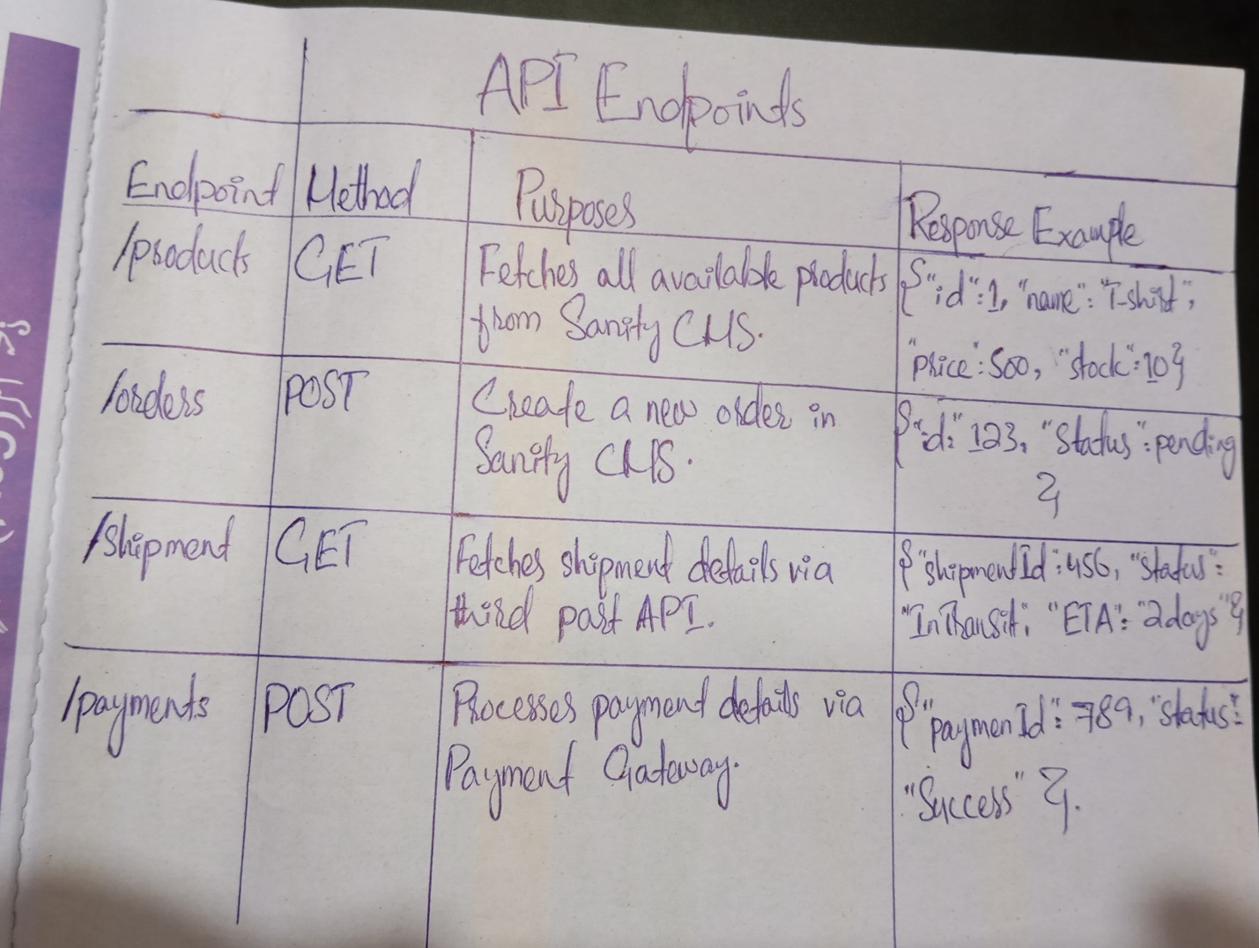**

### ****Sanity Schema Examples****

### ****Product Schema****:

### C:\Users\SBT\AppData\Local\Packages\5319275A.WhatsAppDesktop_cv1g1gvanyjgm\TempState\C1B70D965CA504AA751DDB62AD69C63F\WhatsApp Image 2025-01-24 at 21.25.18_896c2d3d.jpg

### ****Order Schema****:

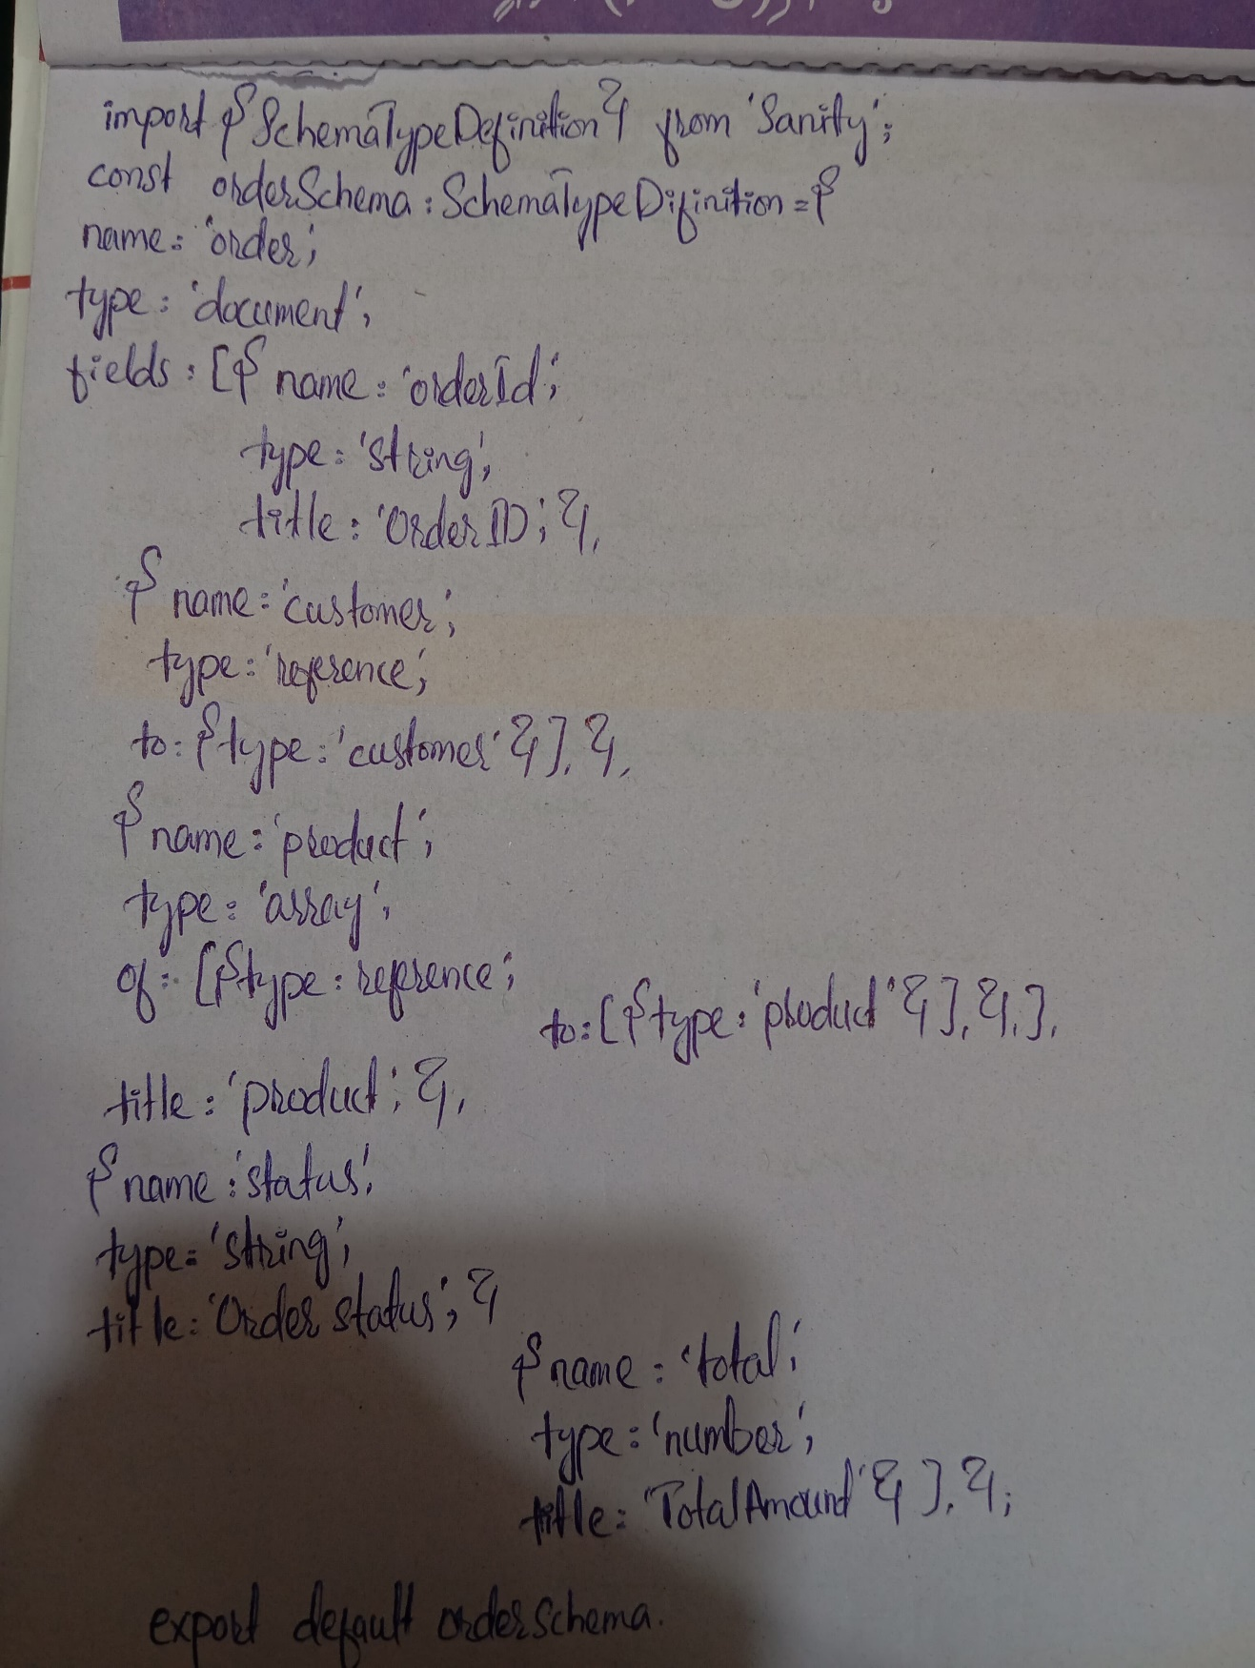

**Customer Schema**:

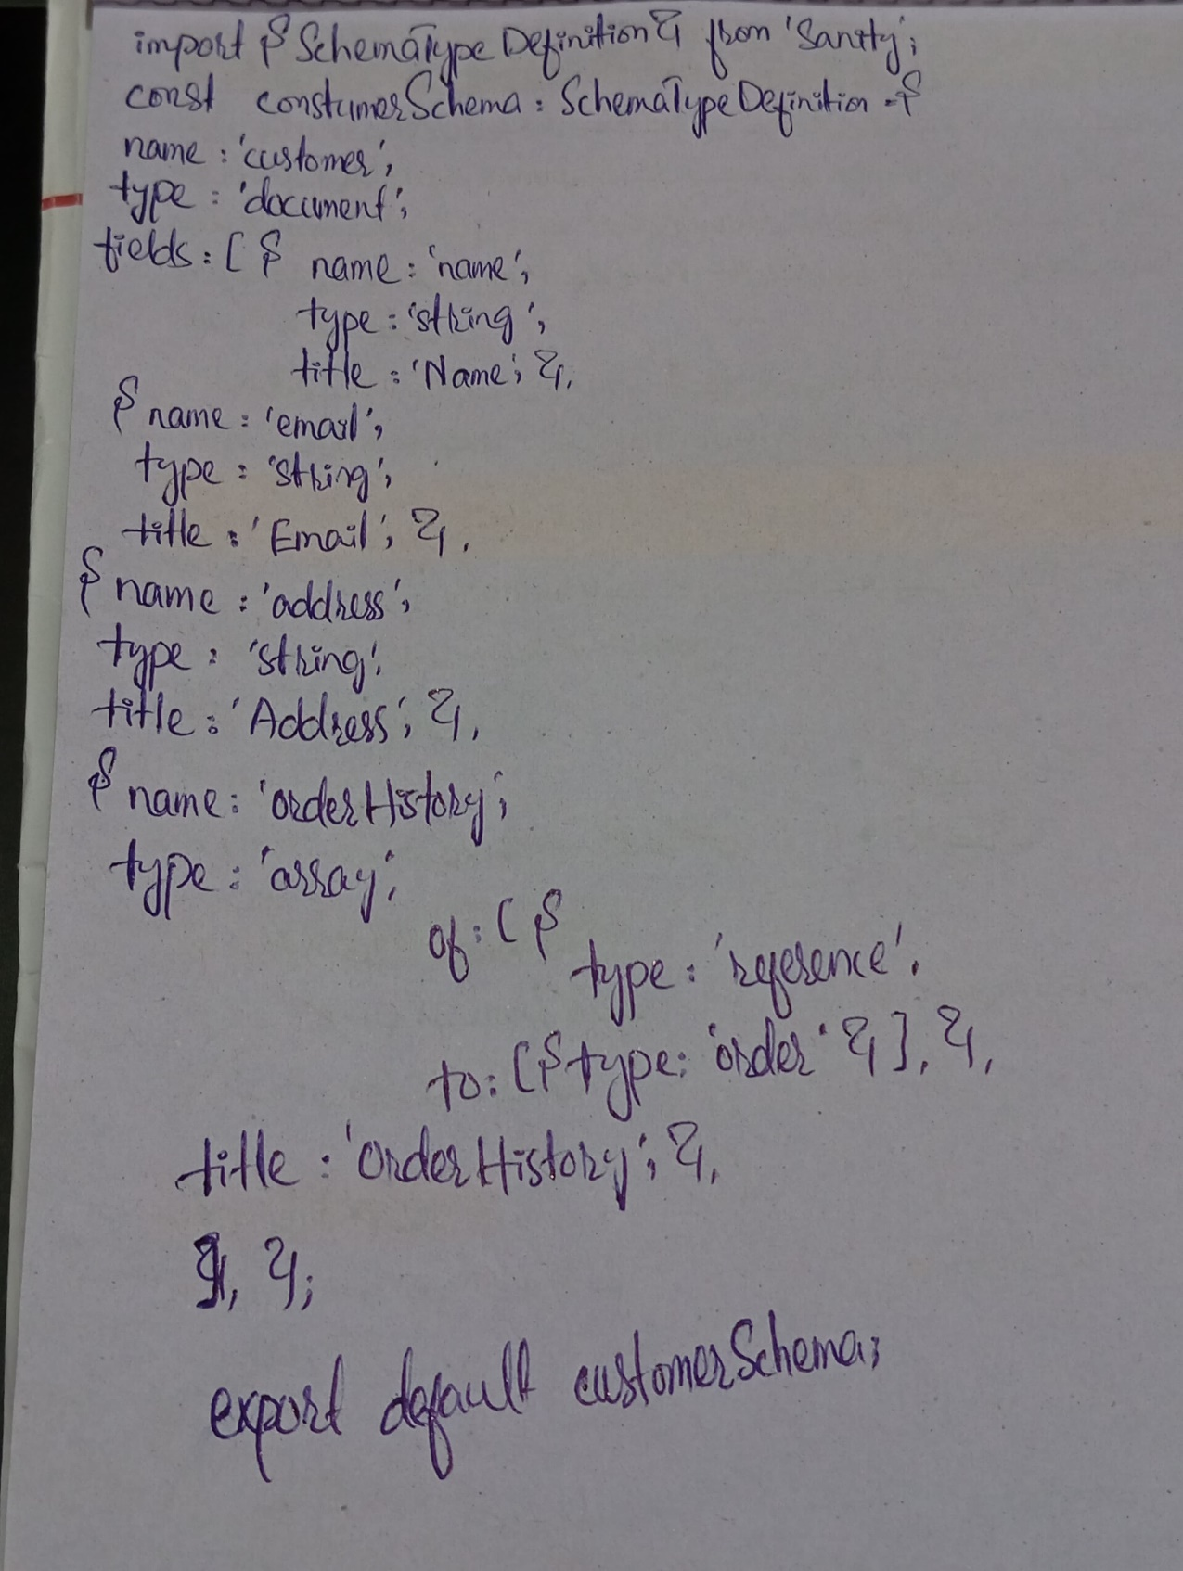

**Collaborative Feedback**

During the refinement phase, I engaged with peers to exchange ideas on system architecture and API design. Key feedback included:

* Enhancing API scalability by introducing pagination for /products.
* Adding clear error responses for APIs (e.g., 404 for invalid product IDs).
* Streamlining workflows for a smoother user experience, especially during checkout.